ePBL Internship Project Report

AI Smart Timetable Scheduler

Domain: Artificial Intelligence
Department: Electronics & Communication Engineering
College: Vardhaman College of Engineering
Team Members
B. Akshay Kumar (23881A04D2)
B. Giri Nayak (23881A04D8)
C. Ravi Teja (23881A04E1)
E. Sumadhar (23881A04F1)
Submission Date: June 30, 2026

Abstract
The AI Smart Timetable Scheduler is a prototype web application that demonstrates AI-inspired timetable scheduling concepts. The system manages faculty, subjects, scheduling parameters and timetable generation through a unified interface while presenting optimization metrics for review.

Introduction
Educational institutions often spend considerable time preparing conflict-free timetables. This project demonstrates an intelligent scheduling workflow that organizes subjects, faculty information, classroom utilization and scheduling parameters in an interactive web application. The system provides an end-to-end solution from login to timetable approval, reducing manual effort and scheduling conflicts significantly.

Problem Statement
Manual timetable preparation is time-consuming and error-prone. Scheduling conflicts between faculty, classrooms, and batches are common and difficult to resolve without a systematic tool. There is no easy way to balance faculty workload or measure the quality of a timetable. This project addresses the need for an intelligent, automated scheduling system that can generate conflict-free timetables while providing measurable optimization metrics.

Objectives
- Simplify timetable generation for academic institutions.
- Reduce scheduling conflicts between faculty, subjects, and classrooms.
- Improve faculty workload balance.
- Demonstrate AI-inspired scheduling concepts.
- Provide optimization metrics and a structured approval workflow.

Existing System
Most academic institutions currently prepare timetables manually using spreadsheets such as Microsoft Excel. These approaches have no automated conflict detection, no faculty workload balancing, and no way to compare multiple timetable options. Approval and revisions are handled informally through email or printed drafts, with no audit trail or structured review process.

Proposed System
The proposed AI Smart Timetable Scheduler is a web-based application that automates timetable generation from data entry to final approval. Administrators configure institutional parameters, manage subjects and faculty, and generate multiple ranked timetable options based on configurable optimization goals. The system displays conflict analysis and optimization metrics so decision-makers can review and approve the best schedule with confidence.

Technologies Used
HTML5, CSS3, JavaScript, Bootstrap 5 and GitHub Pages.

System Workflow
Login → Configure Parameters → Manage Subjects & Faculty → Generate Timetable → Review & Approval → Optimization Metrics

Modules
- Login – Secure entry point for administrators to access the system.
- Dashboard – Overview of classrooms, batches, subjects, faculty, and the current timetable with optimization metrics.
- Scheduling Parameters – Configuration of institutional parameters and optimization weights.
- Subject Management – Add and manage subjects with enrolment, sections, and dependencies.
- Faculty Management – Maintain faculty profiles with workload and availability.
- Generate Timetable – Produces ranked candidate timetables based on selected optimization goals.
- Review & Approve – Review generated timetables with conflict analysis and approve or request changes.

Implementation
The application was built using standard front-end web technologies without a server-side backend, making it lightweight and easy to deploy. Bootstrap 5 components such as cards, sliders, tables, and progress bars are used throughout the interface. JavaScript handles all scheduling logic, parameter validation, and optimization metric computation. The complete application is hosted on GitHub Pages for demonstration.

Results
The prototype successfully demonstrates timetable generation, subject management, faculty management, optimization metrics and timetable approval through an intuitive web interface. The following screenshots show the working modules of the application.
Login Screen
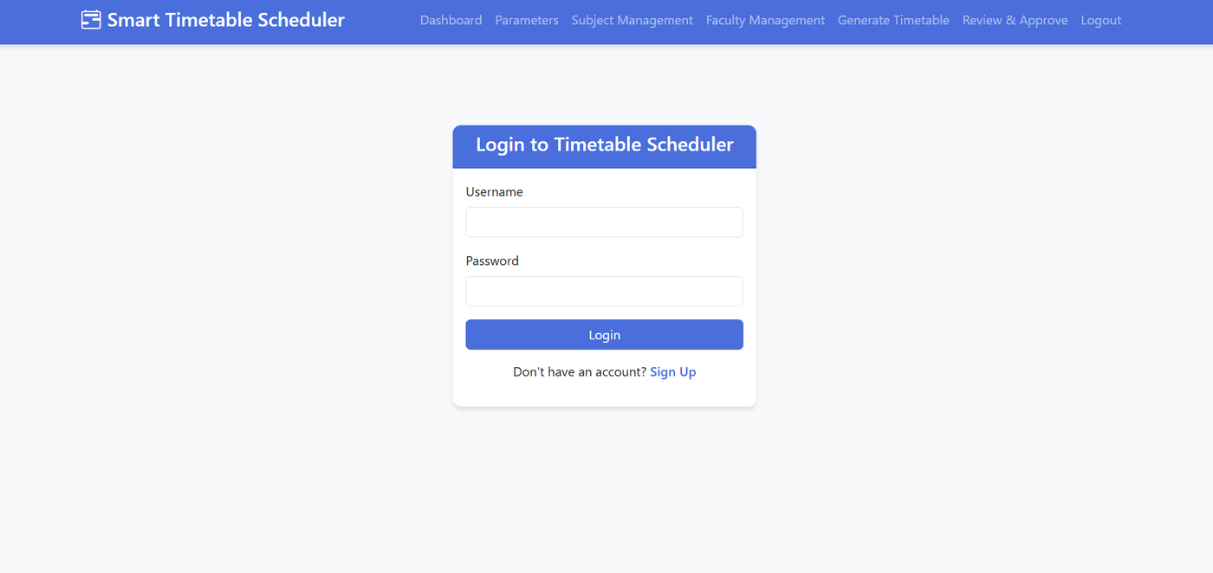
Figure 1 – Login Screen
Dashboard
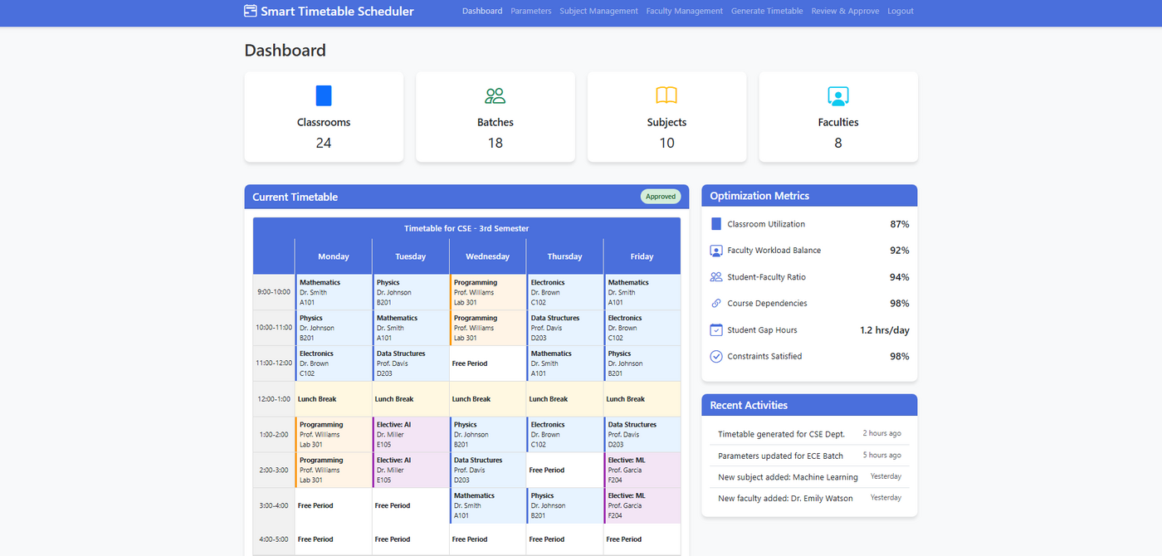
Figure 2 – Dashboard
Scheduling Parameters
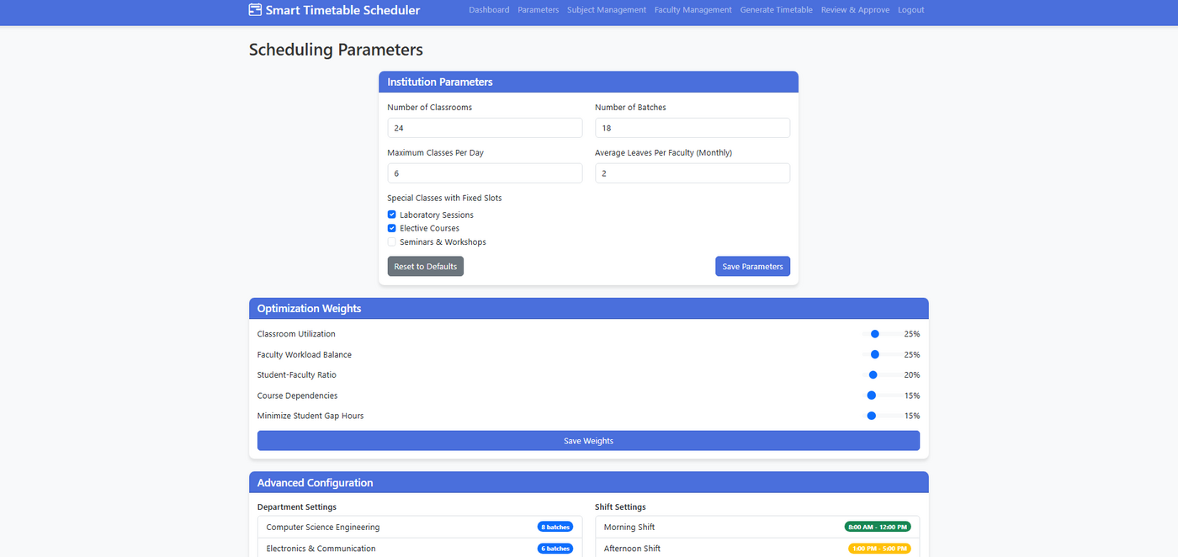
Figure 3 – Scheduling Parameters
Subject Management
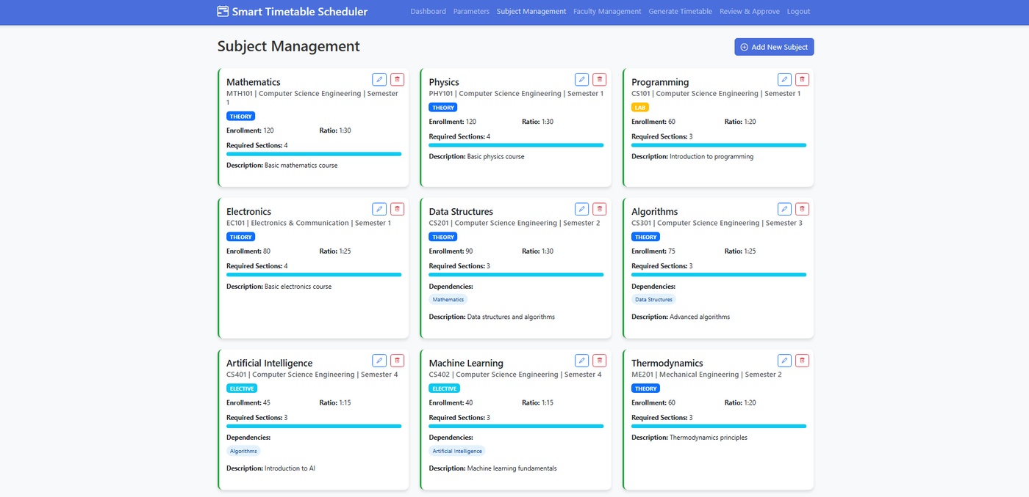
Figure 4 – Subject Management
Faculty Management
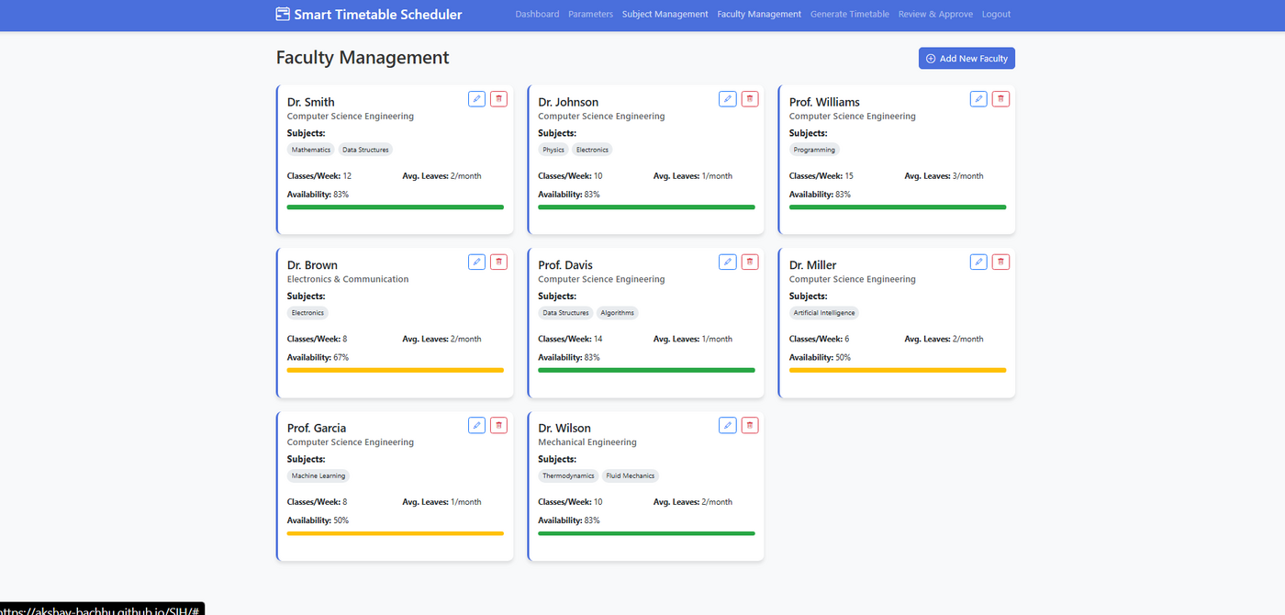
Figure 5 – Faculty Management
Generate Timetable
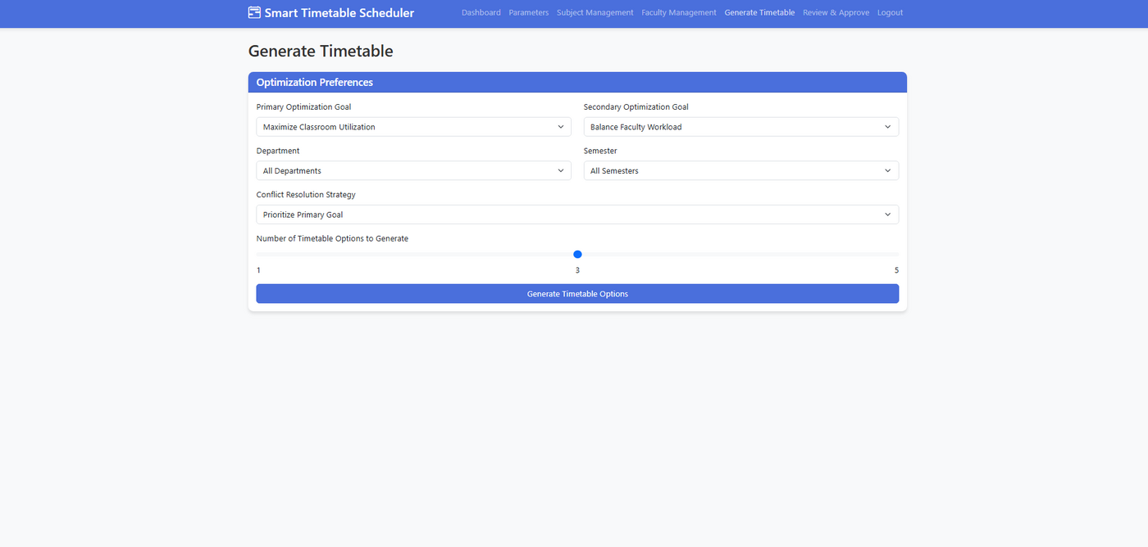
Figure 6 – Generate Timetable
Review & Approve
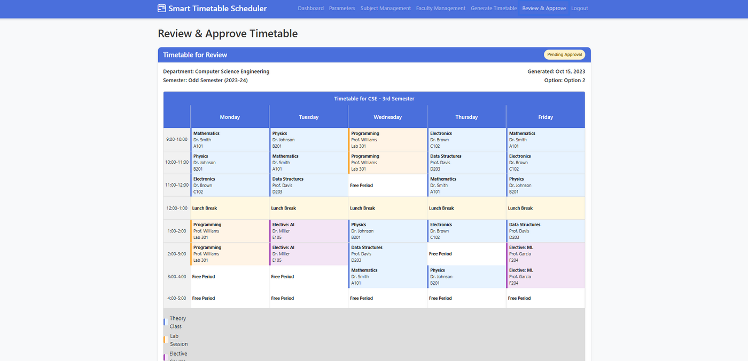
Figure 7 – Review & Approve Timetable
Optimization Suggestions
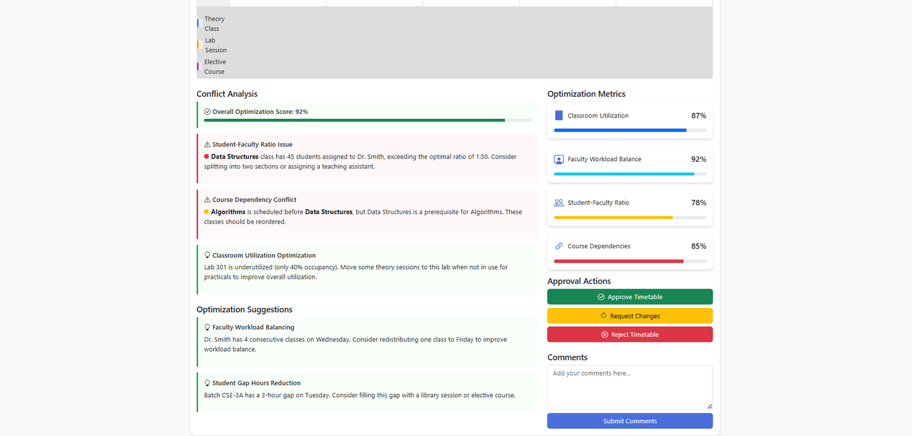
Figure 8 – Optimization Suggestions and Metrics
The application showcases intelligent scheduling concepts with classroom utilization at 87%, faculty workload balance at 92%, and overall constraint satisfaction at 98%, confirming that the scheduling logic works as intended.

Advantages
- Easy to use with an intuitive web interface.
- Reduces manual effort and scheduling conflicts.
- Modular architecture allows independent development of each feature.
- Provides measurable optimization metrics for decision-making.
- Lightweight, browser-based and requires no server installation.
- Ready for future integration with AI-based optimization algorithms.

Future Scope
Future work includes machine learning based optimization using genetic algorithms or constraint solvers, persistent database integration, role-based authentication, cloud deployment, export to PDF and calendar formats, and support for multiple departments and programs running simultaneously.

Conclusion
The AI Smart Timetable Scheduler provides a solid prototype for intelligent timetable management. It successfully demonstrates automated timetable generation, conflict detection, and optimization metric reporting through a clean and easy-to-use web interface. The application serves as a strong foundation for future AI-enabled scheduling systems in academic institutions.

References
[1] Bootstrap Team, “Bootstrap 5 Documentation,” 2023. [Online]. Available: https://getbootstrap.com
[2] Mozilla Developer Network, “HTML, CSS and JavaScript Reference,” MDN Web Docs, 2023. [Online]. Available: https://developer.mozilla.org
[3] GitHub Inc., “GitHub Pages Documentation,” 2023. [Online]. Available: https://pages.github.com
[4] A. Schaerf, “A Survey of Automated Timetabling,” Artificial Intelligence Review, vol. 13, no. 2, pp. 87–127, 1999.
[5] Vardhaman College of Engineering, ePBL Internship Project Guidelines, Dept. of ECE, 2026.

